Académie | Réunion
Niveau | Terminale
Discipline | DNL SES/Anglais
Thème du programme | Sociologie : 1.1 : comment analyser la structure sociale  Theme 3 : Social Inequalities
Notions
Prérequis | - Percentiles, deciles, quintiles  - Definition of income, wealth, social inequalities
Questionnement | - What are the evolution and the extent of inequalities in the world since the beginning of the 20th Century?
Objectifs | SKILLS :  - Read and express different kind of figures measuring the inequalities  - Analyse different results and draw conclusions from them  - Develop and organize an answer  - Improve english oral expression  KNOWLEDGE :  - The rise of inequalities since the middle of the 20th Century  - The difference of inequalities level according to the countries  - The difference between income and wealth inequalities. The fact that wealth inequalities are deeper than income inequalities and its economic explanation
Scénario de la séquence OPTION1 :  Travail individuel et noté effectué dans l’idéal au labo de langues avec casques audio et MP3.  Durée : une heure | - Visit the http://wid.world web site  - Select world view in the menu  - Change the countries the period of time and/or the key indicators when needed to answer to the questions  - Prepare a written answer to the different questions  - Record the different answers on the audio device
Pistes de correction | 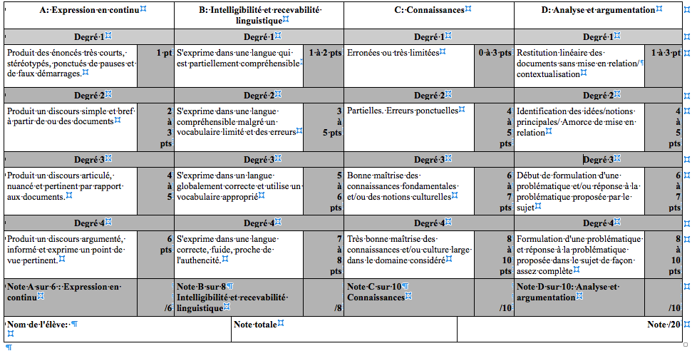  - Use the 40 points of the two last columns to evaluate the quality of the answers  - Use the 12 reamining points to grade the oral expression and the language fluency

OPTION 1 : The Mum’s method
Each one of your answers will be recorded on your audio device.
Please remember to erase the answers that you are not satisfied with, and to keep only the final ones.
Don’t forget to specify the number of the question you are answering to.
You need to illustrate precisely your answers with the figures on the graph.

- Connect yourself to the following website : http://wid.world and select « world view » on the menu
Tool Box
- In the purpose of removing or ading some countries in the graph, you can click on the map above the graph or use the menu on your left : select on the top of the menu country and region and unselect the unnecessary countries.
- To change the period of time, simply use the green line on the bottom of the graph.

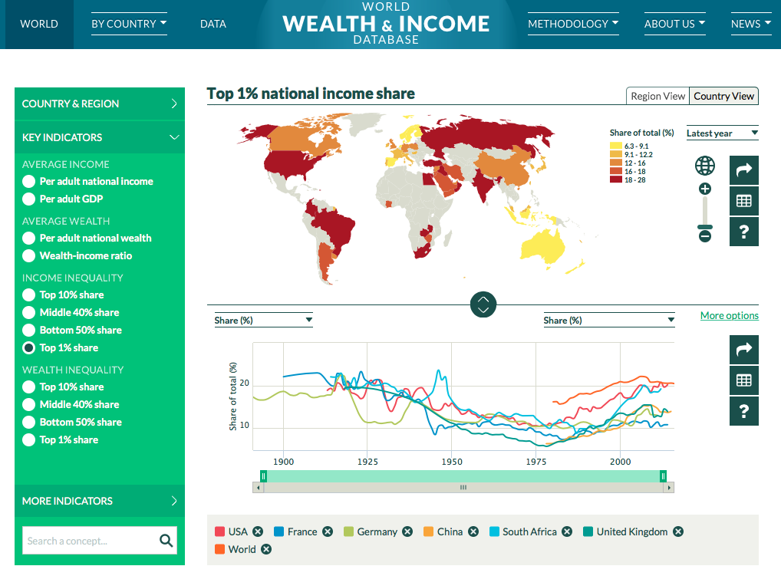

- Explain the meaning of the indicator « Top 1% share » used to measure income inequality.

- Write a full and complete sentence with the World top 10% income share for 2016.

- Add Denmark to the listed countries in the chart. (use the tool box). What can you say about the different results according to each specific countries? Develop and organize your answer.

- Focusing on developed countries and on the two last centuries ( Use the tool box to remove some countries and change the period of time), describe precisely how the income inequalities have changed since the early 20th century. Don’t forget to develop and organize properly your answer ( General trend first then specific periods of change).

- Using your knowledge and the informations on the website ( look everywhere…), explain precisely the expressions « Income inequality » and « wealth inequality » used on the left menu.

- Now, only select The USA as a country and present the top 1% national income share in 1925 and in 2014.

- Do the same with the top 1% net personal wealth share, still in the USA in 1925 and in 2014.

- What can you say about the results difference when comparing income inequalities with the wealth ones? How could you explain it?

Académie | Réunion
Niveau | Terminale
Discipline | DNL SES/Anglais
Thème du programme | Sociologie : 1.1 : comment analyser la structure sociale  Theme 3 : Social Inequalities
Notions
Prérequis | - Percentiles, deciles, quintiles  - Definition of income, wealth, social inequalities
Questionnement | - What are the evolution and the extent of inequalities in the world since the beginning of the 20th Century?
Objectifs | SKILLS :  - Read and express different kind of figures measuring the inequalities  - Search for informations  - Analyse different results and draw conclusions from them  - Develop and organize an answer  - Improve english oral expression  KNOWLEDGE :  - The rise of inequalities since the middle of the 20th Century  - The difference of inequalities level according to the countries  - The difference between income and wealth inequalities. The fact that wealth inequalities are deeper than income inequalities and its economic explanation
Scénario de la séquence OPTION2 :  - Travail à deux ou en petit groupe : 3 maximum  - 10 min de présentation de la séquence et du site  - 40 minutes de travail en autonomie sur le site  - 10 minutes de préparation des interventions orales ( qui dit quoi, relecture des notes)  - 40 minutes de mise en commun et de prise de trace écrite d’éléments de cours. |  | - Visit the http://wid.world web site  - Select world view in the menu  - Change the countries the period of time and/or the key indicators when needed to prove or refute the assertions.  - Prove a point in front of the rest of the class while using the data on the website. Specific and documented notes will be needed

OPTION 2 : The dad’s method

- Chose wisely one classmate and make a workteam.
- Connect yourselves to the following website : http://wid.world and select « world view » on the menu
Tool Box

- In the purpose of removing or ading some countries in the graph, you can click on the map above the graph or use the menu on your left : select on the top of the menu country and region and unselect the unnecessary countries.
- To change the period of time, simply use the green line on the bottom of the graph.

- Using your knowledge and all the figures you can find on the website, prove or refute precisely the following assertions by quoting several results for different countries and/or period of time.

- Nowadays, in several countries the level of inequalities can be compared to the end of the 19th century’s one.

- There has been a rise of inequalities since the middle of the 20th century.

- Today China is the most unequal country in the world.

- Emerging countries are more unequal than developed ones

- Wealth inequalities are more important than income inequalities

